I give permission for my child/ren _______________ _________________in class/es ___________ to participate in the Premier’s Reading Challenge 2014.

I have read the Privacy information and understand that only the child’s name will be published in the Sydney newspaper.

Parent’s/Carer’s signature _______________________________



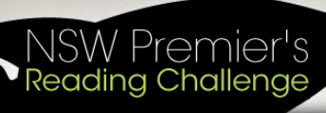

NSW Premier’s Reading Challenge

Permission Note